1. Use HTML text formatting tags to create web page as per given sample.

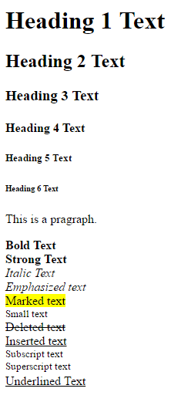

**Code 1:**

<!DOCTYPE html>

<html lang="en" dir="ltr">

<head>

<meta charset="utf-8">

<title>Assignment 1</title>

</head>

<body>

<h1>Heading 1 Text</h1>

<h2>Heading 2 Text</h2>

<h3>Heading 3 Text</h3>

<h4>Heading 4 Text</h4>

<h5>Heading 5 Text</h5>

<h6>Heading 6 Text</h6>

<p>This is a paragraph</p>

<pre>

<b>Bold text</b>

<strong>Strong Text</strong>

<i>Italic Text</i>

<em>Emphasized text</em>

<mark>Marked text</mark>

<small>Small text</small>

<del>Deleted text</del>

<ins>Insersted text</ins>

<sub>Subscript text</sub>

<sup>Superscript text</sup>

<u>Underlined Text</u>

</pre>

</body>

</html>

1. Use hyper link tag to navigate through different web pages as per given sample.

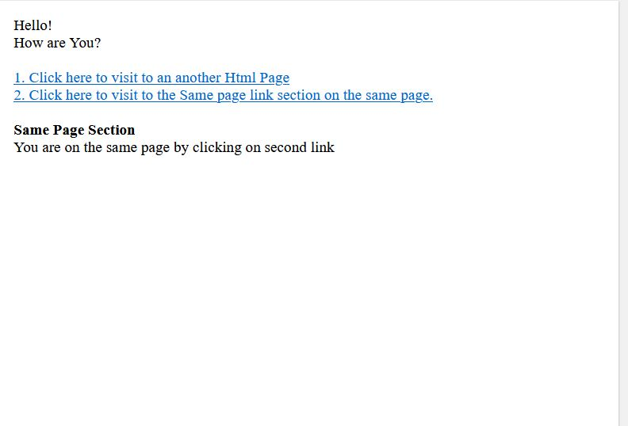

**Code 2:**

<!DOCTYPE html>

<html lang="en" dir="ltr">

<head>

<meta charset="utf-8">

<title>Assignment 2</title>

</head>

<body>

<p>Hello! <br> How are You? </p>

<ol>

<li><a href="https://youtu.be/gru-rLjIRpg">Click here to visit to an Html Page</a></li>

<li><a href="#same">Click here to visit to the same page link section on the same page.</a></li>

</ol>

<section>

<h1 id="same">Same Page Section</h1>

<p>You are on the same page by clicking on second link</p>

</section>

</body>

</html>

1. Use image tags to create web page as per given sample. ( Take any 3 images and align them to right, left and centre like given below sample)



**Code 3:**

<!DOCTYPE html>

<html lang="en" dir="ltr">

<head>

<meta charset="utf-8">

<title>Assignment 3</title>

<style media="screen">

img {

display: block;

margin-left: auto;

margin-right: auto;

}

</style>

</head>

<body>

<img src="http://www.shutterstock.com/blog/wp-content/uploads/sites/5/2016/03/fall-trees-road-1.jpg" alt="pic1" width="1440" height="900" align="left">

<img src="https://tse4.mm.bing.net/th?id=OIP.whn-n7GS5FvQUbfvFUMUxQHaEo&pid=Api&P=0&w=244&h=153" alt="pic3" width="1440" height="900" align="right">

<img src="http://asia.olympus-imaging.com/content/000090033.jpg" alt="pic2" width="1333" height="1000">

</body>

</html>

1. Use HTML table tags to create web page as per given sample.

(Put following code under <head> tag to create border.)

<style>

table, th, td {

border: 1px solid black;

}

</style>

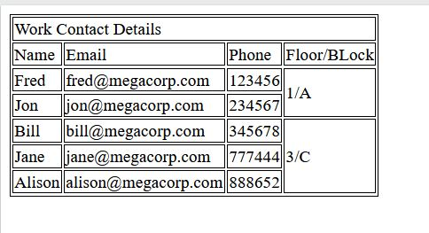

**Code 4:**

<!DOCTYPE html>

<html lang="en" dir="ltr">

<head>

<meta charset="utf-8">

<title>assignment 4</title>

<style>

table, th, td {

border: 1px solid black;

}

</style>

</head>

<body>

<table>

<tr>

<th colspan="4" align="left">Work Contact Details</th>

</tr>

<tr>

<td>Name</td>

<td >Email</td>

<td>Phone</td>

<td>Floor/Block</td>

</tr>

<tr>

<td>Fred</td>

<td>fred@megacorp.com</td>

<td>123456</td>

<td rowspan="2">1/A</td>

</tr>

<tr>

<td>Jon</td>

<td>jon@megacorp.com</td>

<td>234567</td>

</tr>

<tr>

<td>Bill</td>

<td>bill@megacorp.com</td>

<td>34567</td>

<td rowspan="3">3/C</td>

</tr>

<tr>

<td>Jane</td>

<td>jane@megacorp.com</td>

<td>777444</td>

</tr>

<tr>

<td>Alison</td>

<td>alison@megacorp.com</td>

<td>888652</td>

</tr>

</table>

</body>

</html>

1. Use sorted list to create web page as per given sample page.

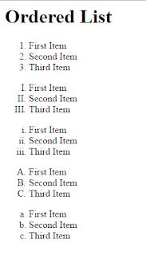

**Code 5:**

<!DOCTYPE html>

<html lang="en" dir="ltr">

<head>

<meta charset="utf-8">

<title>assignment 5</title>

</head>

<body>

<h1>Ordered List</h1>

<ol>

<li>First Item</li>

<li>Second Item</li>

<li>Third Item</li>

</ol>

<ol type="I">

<li>First Item</li>

<li>Second Item</li>

<li>Third Item</li>

</ol>

<ol type="i">

<li>First Item</li>

<li>Second Item</li>

<li>Third Item</li>

</ol>

<ol type="A">

<li>First Item</li>

<li>Second Item</li>

<li>Third Item</li>

</ol>

<ol type="a">

<li>First Item</li>

<li>Second Item</li>

<li>Third Item</li>

</ol>

</body>

</html>

1. Use unsorted list to create web page as per given sample page.

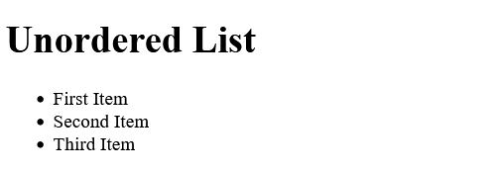

**Code 6:**

<!DOCTYPE html>

<html lang="en" dir="ltr">

<head>

<meta charset="utf-8">

<title>assignment 6</title>

</head>

<body>

<h1>Unordered List</h1>

<ul>

<li>First Item</li>

<li>Second Item</li>

<li>Third Item</li>

</ul>

</body>

</html>

1. 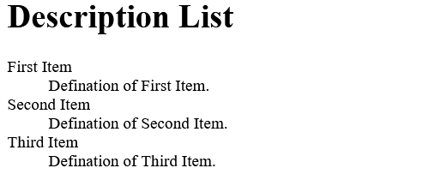Use definition list to create web page as per given sample page.

**Code 7:**

<!DOCTYPE html>

<html lang="en" dir="ltr">

<head>

<meta charset="utf-8">

<title>assignment 7</title>

</head>

<body>

<h1>Description List</h1>

<dl>

<dt>First Item</dt>

<dd>Defination of First Item</dd>

<dt>Second Item</dt>

<dd>Defination of Second Item</dd>

<dt>Third Item</dt>

<dd>Defination of Third Item</dd>

</dl>

</body>

</html>